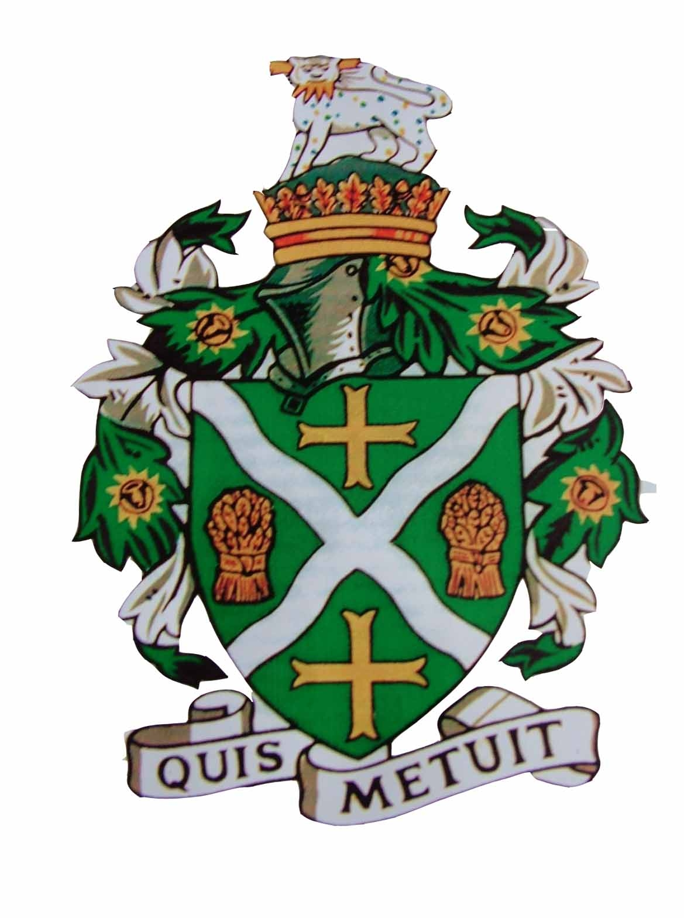

Sturminster Newton Town

Council Grant Application Form

Grants will be considered between £100 - £750

Name of organisation
Registered charity number (if applicable)
Contact name
Address
Daytime telephone number
Email address
Aims and objectives of your organisation and how they fit with the Council’s priority to:
- Improve the quality of life for residents in Sturminster Newton

Please explain how these objectives are currently achieved.

Amount requested | £
Purpose of the request – Please provide the details of the project and
whether other sources of funding that have been agreed or applied for.
How many Sturminster Newton residents will benefit?
Any further relevant information
Signed: | Dated:

Checklist - Guidance notes

Please ensure that you have fully completed the application form and enclosed the following information.
- Last set of accounts for established organisations
or
latest bank statement or if you are a new organisation with details of income and expenditure to date, and a forecast for the project costs.

- Supporting documents – anything else you think will help describe your project – no more than one side of A4 typing and/or 2 photos or one video link.

- By signing this form you give Sturminster Newton Town Council permission to use the information that you provide:

  - To establish your entitlement to a grant
  - To administer the application and analyse applications and grants

Please return this form together with attachments to:
The Town Clerk
Sturminster Newton Town Council
Old Market Hill
Sturminster Newton Dt101 FH

Email: admin@sturminsternewton-tc.gov.uk

