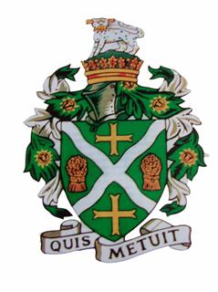
STURMINSTER NEWTON TOWN COUNCIL
Council Offices, Old Market Hill, Sturminster Newton DT10 1FH
Tel: 01258 475136 Email: admin@sturminsternewton-tc.gov.uk

There is an Extraordinary Meeting of the Town Council which will be held on Thursday 18th August 2022 at 7.15pm.
Members are reminded that the Council has a general duty to consider the following matters in the exercise of any of its functions: Equal Opportunities (race, gender, sexual orientation, marital status, religion, belief or disability), Crime & Disorder, Health and Safety and Human Rights.
Only Agenda items where the indicated function is to approve or decide may be decided at this meeting. Other items are for information only and no decision can be taken upon them unless and until raised at a later meeting.

22/23/089 | Apologies for Absence.
22/23/090 | To receive declarations of interests and approve any written applications for dispensations.
22/23/091 | To approve the minutes of the previous Town Council meeting held on 21st July 2022 – attached.
22/23/092 | Recall of decisions made by Council
 | Pursuant to Standing Orders 7a Council have received notice from the required number of members regarding decision 22/23/088 !, relating to the Youth Hub project.
22/23/093 | TO EXCLUDE PUBLIC AND PRESS  In exercise of the power conferred by the Public Bodies (Admission to Meetings) Act 1960, Section 1(2) members of the public and press will be excluded from the Meeting on the grounds that the business to be transacted being of a confidential nature it is likely that personal and/or exempt information would otherwise be improperly disclosed and members would feel unable to discuss the matter freely.
22/23/094 | CONFIDENTIAL ITEM  Youth Hub Project Update and agree further actions

Signed: Kate Squire - Town Clerk 12th Aug 2022

