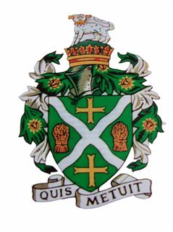
STURMINSTER NEWTON TOWN COUNCIL
Council Offices, Old Market Hill, Sturminster Newton DT10 1FH
Tel: 01258 475136 Email: admin@sturminsternewton-tc.gov.uk

There is a meeting of the Town Council which will be held on
Thursday 7th July 2022 at 7.15pm in The Council Chamber.
Members are reminded that the Council has a general duty to consider the following matters in the exercise of any of its functions: Equal Opportunities (race, gender, sexual orientation, marital status, religion, belief or disability), Crime & Disorder, Health and Safety and Human Rights.
Only Agenda items where the indicated function is to approve or decide may be decided at this meeting. Other items are for information only and no decision can be taken upon them unless and until raised at a later meeting.

22/23/052 | To receive comments and questions from members of the public. Members of the public are invited to raise any matter and speak for up to three minutes. The Council cannot discuss matters raised unless they already appear on this Agenda.
22/23/053 | Apologies for Absence.
22/230/54 | To receive declarations of interests and approve any written applications for dispensations.
22/23/055 | To approve the minutes of the previous Town Council meeting held on 9th June 2022 – attached.
To approve recommendations from the following committee meetings:

- Amenities Committee – 16th June 2022

22/23/056 | Planning Applications – see attached.
22/23/057 | Discuss public consultation of possible Manston Road development.
22/23/058 | Alpha Housing – Purchase of strip of Town Council land, set terms.
22/23/059 | To receive correspondence and discuss any issues raised.
22/23/060 | To receive a report from the Town Clerk.
22/23/061 | To receive a report from the Town Mayor
22/23/062 | To receive a report from Dorset Councillor Carole Jones.
22/23/063 | To receive information from members and discuss proposals for future business.

Kate Squire – Town Clerk 1st July 2022

