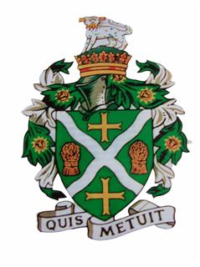
STURMINSTER NEWTON TOWN COUNCIL
Council Offices, Old Market Hill, Sturminster Newton DT10 1FH
Tel: 01258 475136 Email: admin@sturminsternewton-tc.gov.uk

There will be an EXTRAORDINARY meeting of the TOWN COUNCIL which will be held on
Thursday 25th February 2021 at 7.15pm on ZoomUS.

This meeting will be held in accordance with The Local Authorities and Police and Crime Panels (Coronavirus) (Flexibility of Local Authority and Police and Crime Panel Meetings) (England and Wales) Regulations 2020 (“the 2020 Regulations”) which came in to force on 4th April 2020. Members of the public are invited to join the meeting using the meeting ID and password. If, as a member of the public, you wish to speak in the Public Session, please notify the Town Clerk prior to the meeting via admin@sturminsternewton-tc.gov.uk or 01258 475136. Members are reminded that the Council has a general duty to consider the following matters in the exercise of any of its functions: Equal Opportunities (race, gender, sexual orientation, marital status, religion, belief or disability), Crime & Disorder, Health and Safety and Human Rights.
Only Agenda items where the indicated function is to approve or decide may be decided at this meeting. Other items are for information only and no decision can be taken upon them unless and until raised at a later meeting.

Mal Derricott - Acting Town Clerk 17.02.2021

Apologies for absence

TC/174/21. To receive declarations of interests and approve any written applications for dispensations.

TC/175/21. CONFIDENTIAL ITEM

In exercise of the power conferred by the Public Bodies (Admission to Meetings) Act 1960, Section 1(2) members of the public and press will be excluded from the Meeting on the grounds that the business to be transacted being of a confidential nature it is likely that personal and/or exempt information would otherwise be improperly disclosed and members would feel unable to discuss the matter freely.

TC/176/21. STAFFING AND PERSONNEL MATTERS

