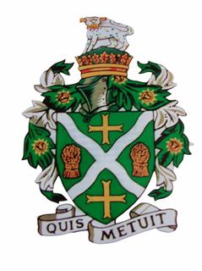
STURMINSTER NEWTON TOWN COUNCIL
Council Offices, Old Market Hill, Sturminster Newton DT10 1FH
Tel: 01258 475136 Email: admin@sturminsternewton-tc.gov.uk

There will be a meeting of the Finance and Personnel Committee on THURSDAY 29th. APRIL 2021, which will be held on ZOOM at 7.15pm. Meeting ID: 862 1971 5991
Passcode: 703519
This meeting will be held in accordance with The Local Authorities and Police and Crime Panels (Coronavirus) (Flexibility of Local Authority and Police and Crime Panel Meetings) (England and Wales) Regulations 2020 (“the 2020 Regulations”) which came in to force on 4th April 2020. Members of the public are invited to join the meeting using the meeting ID and password. If, as a member of the public, you wish to speak in the Public Session, please notify the Town Clerk prior to the meeting via admin@sturminsternewton-tc.gov.uk or 01258 475136. Members are reminded that the Council has a general duty to consider the following matters in the exercise of any of its functions: Equal Opportunities (race, gender, sexual orientation, marital status, religion, belief or disability), Crime & Disorder, Health and Safety and Human Rights.
Only agenda items where the indicated function is to approve or decide may be decided at this meeting. Other items are for information only and no decision can be taken upon them unless and until raised at a later meeting.

To receive apologies for absence

20/65 To receive comments and questions from members of the public.
Members of the public are invited to raise any matter and speak for up to three minutes. The Council cannot discuss matters raised unless they already appear on this Agenda.

20/66 To receive declarations of interests and approve any written applications for dispensations.

20/67 To Approve the Minutes of the previous Finance and Personnel Committee Meeting held on 28th. January 2021.

20/68 To approve the Statement of accounts as at 31.03.2021.

20/69 To approve the budget comparison as at 31.03.2021.

20/70 To approve payments for invoices in excess of £2000.

20/71 To receive a report on the payments made under delegation between 01.01.2021 and 31.3.2021 and confirm a sample of payments made between these dates had been checked by Cllrs Lacey and Janes.

20/72 To Review the Shillingstone Parish Council Service Level Agreement (SLA).

20/73 To Consider a Grant towards the Town Centre Christmas Lights.

20/74 To receive information from members and discuss proposals for future business.

Mal Derricott - Acting Town Clerk Dated: 23.04.2021

