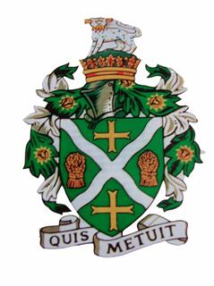
STURMINSTER NEWTON TOWN COUNCIL
Council Offices, Old Market Hill, Sturminster Newton DT10 1FH
Tel: 01258 475136
Email: admin@sturminsternewton-tc.gov.uk

To: All Town Councillors
Dear Member,
You are hereby summoned to attend an extraordinary meeting of the Town Council which will be held on Monday 23rd March 2020 at Council Offices, Old Market Hill, Sturminster Newton at 7.15pm to transact the business set out in the Agenda below.

EML Lindsay Emma Lindsay - Town Clerk 17.03.2020

Members of the public and press are welcome to attend in accordance with the Public Bodies (Admission to meetings) Act 1960

Agenda
No. | Agenda item | Time (est.)
1 | To receive comments and questions from members of the public | 15 mins
2 | Members of the public are invited to raise any matter and speak for up to five minutes. The Chairman will normally permit visitors to speak at other times only in order to provide information and if specifically asked to do so. The Council cannot discuss matters raised unless they already appear on this agenda.
3 | To receive and if agreed approve apologies for absence | 1 min
4 | To receive declarations of interests and approve any written applications for dispensations | 1 min
5 | To approve the minutes of the previous meeting held on 05.03 2020 | 1 min
6 | To receive and consider a report regarding the COVID -19 virus and proposed business continuity arrangements | 30 mins

