_

STURMINSTER NEWTON TOWN COUNCIL

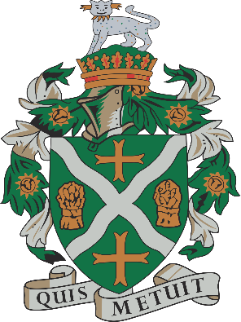

Grounds Operative
16 hours per week
Permanent Contract

The successful candidate will enjoy working outdoors on a broad range of tasks, to maintain and improve the environment in Sturminster Newton. They will be able to work as part of a small team and take direction from the Grounds Manager.
This is a highly varied role including grass cutting, planting, watering and weeding, along with other grounds services and maintenance work.
The salary will be in accordance with NJC recommendations at within the range of scale points 5 to 6 (currently £11.21 to £11.42 per hour.)
The closing date for applications is the 11th May 2023
Interviews will be on the 25th May 2023
For an application form and more details please see our website
www.sturminsternewton-tc.gov.uk

